ECA0901 – DIGITAL SIGNAL PROCESSING

C02-A3 SIMULATION EXPERIMENT – 7
Design and Analysis of FIR Filters Using Parks–McClellan and Frequency-Sampling Techniques Using MATLAB
CODE:
clc; clear; close all;
Fs = 1000; N = 20;
F = [0 0.2 0.3 1];
A = [1 1 0 0];
h1 = firpm(N,F,A,[1 10]);
h2 = fir2(N,F,A);
disp('Parks-McClellan Coefficients:'); disp(h1);
disp('Frequency-Sampling Coefficients:'); disp(h2);
[H1,f] = freqz(h1,1,1024,Fs);
H2 = freqz(h2,1,1024,Fs);
figure;subplot(2,1,1);
plot(f,abs(H1),'b',f,abs(H2),'r');
grid on;title('Magnitude Response');
legend('Parks-McClellan','Frequency Sampling');
subplot(2,1,2);
plot(f,unwrap(angle(H1)),'b',f,unwrap(angle(H2)),'r');
grid on;title('Phase Response');
legend('Parks-McClellan','Frequency Sampling');
disp('FIR filter design completed successfully.');

OUTPUT:
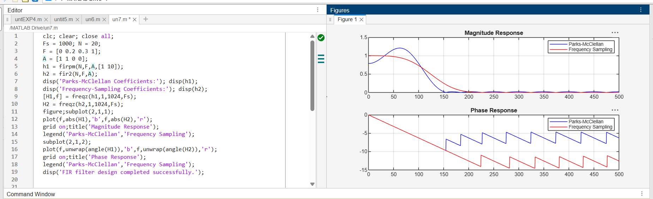
OUTPUT PARAMETERS:
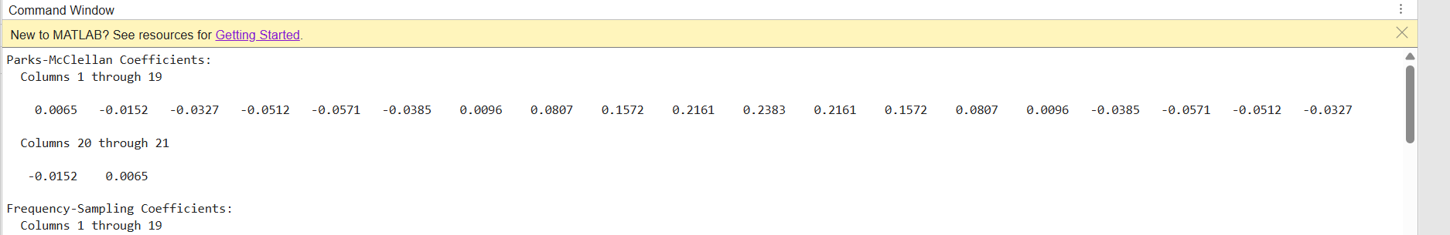
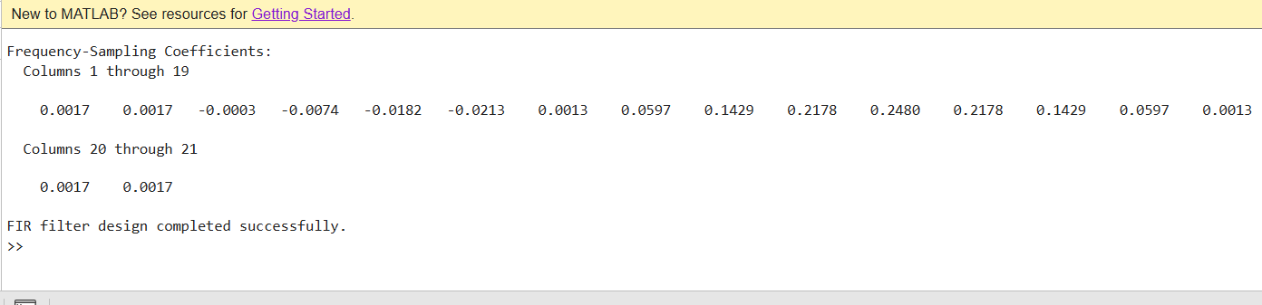
RESULT:
Thus, FIR filters were designed using the Parks–McClellan and frequency-sampling methods. Their coefficients, magnitude and phase responses, passband ripple, and stopband attenuation were evaluated and compared.

